A Project Report

POLICY-GROUNDED AGENTIC AI FOR HEALTH INSURANCE CLAIM DENIAL ANALYSIS AND APPEAL SUPPORT

Submitted in partial fulfillment of the requirements for the award of degree

BACHELOR OF ENGINEERING
in
COMPUTER SCIENCE AND ENGINEERING

by
PRAGALLAPATI SAKETH (160123733129)
SAKETH VEMULAPATI (160123733136)

Under the Supervision of
A. SANGEETHA
Assistant Professor, Dept. of CSE



Department of Computer Science and Engineering,
Chaitanya Bharathi Institute of Technology (Autonomous),
(Affiliated to Osmania University, Hyderabad)
Hyderabad, TELANGANA (INDIA) - 500 075
[2026-2027]


CERTIFICATE
This is to certify that the project titled “Policy-Grounded Agentic AI for Health Insurance Claim Denial Analysis and Appeal Support” is the bonafide work carried out by PRAGALLAPATI SAKETH (160123733129) and SAKETH VEMULAPATI (160123733136), students of B.E. (CSE) of Chaitanya Bharathi Institute of Technology (A), Hyderabad, affiliated to Osmania University, Hyderabad, Telangana (India) during the academic year 2026-2027, submitted in partial fulfillment of the requirements for the award of the degree in Bachelor of Engineering (Computer Science and Engineering) and that the project has not formed the basis for the award previously of any other degree, diploma, fellowship or any other similar title.

Supervisor  A. Sangeetha  Assistant Professor,  Dept. of CSE, CBIT | Project Coordinator(s)  (Name and Designation)

Place: Hyderabad
Date:

DECLARATION
We hereby declare that the project entitled “Policy-Grounded Agentic AI for Health Insurance Claim Denial Analysis and Appeal Support” submitted for the B.E. (CSE) degree is our original work and the project has not formed the basis for the award of any other degree, diploma, fellowship or any other similar titles.

PRAGALLAPATI SAKETH (160123733129)
SAKETH VEMULAPATI (160123733136)
Name(s) and Signature(s) of the Students
Place: Hyderabad
Date:

ABSTRACT
A health insurance claim that is denied leaves the policyholder with a difficult task. They have to work out which clauses of a long policy the insurer relied on, check those clauses against the discharge summary, test reports and hospital bill, look for exceptions or regulatory protections that might apply, and write a formal appeal within the time allowed by the grievance process. Few policyholders have the medical, legal and insurance knowledge this requires, and denials that could be overturned are often accepted.
This project designs a policy-grounded, multi-agent AI system that analyzes a denied claim and, when the evidence supports it, prepares an appeal for Indian retail health insurance. A review of current research shows that existing methods handle separate parts of the problem, such as extracting rules from policy text, linking diagnoses to standard codes, retrieving clinical evidence, predicting appeal outcomes and drafting letters, but none connects the denial notice, the governing clauses, the case evidence and the appeal in one traceable process. The same work shows that language models often reach correct decisions with weak justifications and write appeals with unsupported statements or invented references.
The proposed system parses the uploaded documents, normalizes diagnoses and procedures, and assigns the denial to one of seven categories: medical necessity, pre-existing disease and waiting periods, policy exclusions, financial limits, documentation, administrative grounds, and eligibility. A dedicated investigation for each category collects evidence into an evidence matrix. Explicit rules handle dates, amounts and conditions, and Toulmin-style arguments handle exceptions. Every clause and quotation in a draft appeal is verified against the source documents, and a qualified reviewer approves the final dossier. The knowledge base is built from thirteen policy wordings of four Indian insurers, standard code sets and IRDAI schedules. Component-level benchmarks with defined metrics are designed to evaluate each stage of the system separately.
TABLE OF CONTENTS
ABSTRACT
LIST OF FIGURES
LIST OF TABLES
LIST OF ABBREVIATIONS
INTRODUCTION
1.1 Background and Motivation
1.2 Problem Statement
1.3 Objectives
1.4 Methodology Overview
1.5 Scope and Limitations
1.6 Organization of the Report
LITERATURE SURVEY
2.1 Related Research Studies
2.1.1 Extracting Rules from Policy Text
2.1.2 Retrieving Relevant Policy Text
2.1.3 Linking Clinical Terms to Standard Codes
2.1.4 Retrieving and Assessing Clinical Evidence
2.1.5 Predicting Appeal Outcomes
2.1.6 Reasoning over Policy Conditions and Exceptions
2.1.7 Generating Appeal Letters
2.2 Comparative Analysis of Existing Solutions
2.3 Research Gaps Identified
2.4 Tools and Technologies Used
PROPOSED METHODOLOGY
3.1 System Architecture
3.1.1 Document Intake
3.1.2 Preprocessing and Information Extraction
3.1.3 Category-Specific Investigation Engine
3.1.4 Evidence Matrix
3.1.5 Assessment
3.1.6 Appeal Generation and Human Review
3.1.7 Knowledge Base
3.1.8 Deployment View
3.2 Data Flow and UML Diagrams
3.2.1 Data Flow Diagram, Level 0
3.2.2 Data Flow Diagram, Level 1
3.2.3 Use Case Diagram
3.2.4 Class Diagram
3.2.5 Sequence Diagram
3.2.6 Activity Diagram
3.2.7 State Diagram
3.3 Algorithm Design
3.3.1 Overall Orchestration
3.3.2 Hybrid Clause Retrieval with Exception Attachment
3.3.3 Chronology and Moratorium Check
3.3.4 Room-Rent and Non-Payable Item Audit
3.3.5 Toulmin-Based Applicability Evaluation
3.3.6 Citation Verification and Forum Selection
3.4 Model Description
3.4.1 Agents and Models
3.4.2 Knowledge Resources
3.4.3 Evaluation Benchmarks
3.4.4 Evaluation Metrics
3.5 Innovation and Novelty
REFERENCES

LIST OF FIGURES
Fig 3.1: Proposed system architecture for claim denial analysis and appeal support
Fig 3.2: Component and deployment diagram of the proposed system
Fig 3.3: Data flow diagram, Level 0 (context diagram)
Fig 3.4: Data flow diagram, Level 1
Fig 3.5: Use case diagram
Fig 3.6: Class diagram
Fig 3.7: Sequence diagram for processing a denied claim
Fig 3.8: Activity diagram of the denial analysis workflow
Fig 3.9: State diagram of a case

LIST OF TABLES
Table 2.1: Comparison of representative AI approaches relevant to claim denial analysis
Table 2.2: Tools and technologies used in the project
Table 3.1: Denial categories and their investigations
Table 3.2: Knowledge resources used by the system
Table 3.3: Component-level evaluation benchmarks

LIST OF ABBREVIATIONS
Abbreviation | Expansion
AI | Artificial Intelligence
API | Application Programming Interface
BM25 | Best Matching 25 (ranking function)
CARC | Claim Adjustment Reason Code
CMS | Centers for Medicare and Medicaid Services (U.S.)
CPT | Current Procedural Terminology
DFD | Data Flow Diagram
EHR | Electronic Health Record
HCPCS | Healthcare Common Procedure Coding System
HITL | Human-in-the-Loop
ICD-10-CM | International Classification of Diseases, Tenth Revision, Clinical Modification
IRDAI | Insurance Regulatory and Development Authority of India
LLM | Large Language Model
MCP | Model Context Protocol
MRR | Mean Reciprocal Rank
NME | Non-Medical Expenses
OCR | Optical Character Recognition
PED | Pre-Existing Disease
RAG | Retrieval-Augmented Generation
RARC | Remittance Advice Remark Code
RRF | Reciprocal Rank Fusion
UML | Unified Modeling Language
WHO | World Health Organization

CHAPTER 1

INTRODUCTION

1.1 Background and Motivation
Health insurance has become the main way most Indian families pay for hospital treatment. A retail health policy is a long legal document. It defines what counts as hospitalization, lists the treatments that are covered, sets waiting periods for pre-existing and specified diseases, caps room rent and certain procedures, and names a set of exclusions. Many of those exclusions carry exceptions of their own, often printed several pages away from the exclusion itself.
When a claim is rejected, the insurer issues a repudiation letter. The letter usually quotes a clause number and a short reason such as "elective procedure", "pre-existing disease not disclosed" or "non-medical expenses". It rarely explains how the reason applies to the patient's records. To respond, the policyholder has to read the policy wording, find the clause that was cited, check whether an exception applies, compare the claim against the discharge summary, test results and itemized bill, and then write a formal appeal. The Insurance Regulatory and Development Authority of India (IRDAI) provides a grievance process for this. The complaint goes first to the insurer's grievance redressal officer. If the insurer rejects it or does not reply within one month, the policyholder can approach the Insurance Ombudsman within one year, for claims of up to fifty lakh rupees, or go to a consumer disputes commission.
Most policyholders do not have the medical, legal and insurance knowledge that this process assumes. A denial may also be wrong in ways that are hard to see without that knowledge. An exclusion may have been applied without its exception, a waiting period may already have expired, the statutory moratorium may protect the policy from non-disclosure objections, or the insurer may have deducted consumables that IRDAI guidelines treat as payable. Each of these mistakes can be checked against documents the policyholder already has, if someone reads them carefully and in the right order.
Recent progress in large language models (LLMs), retrieval-augmented generation (RAG) and multi-agent systems makes it possible to automate much of this reading. These tools also bring familiar risks. LLMs produce fluent text that may cite clauses that do not exist, and a single prompt over a forty-page policy can miss the one sub-clause that matters. This project was started to find out how far these methods can be combined with explicit rules and human review to give policyholders a dependable, evidence-based analysis of a denial and, where justified, a draft appeal.

1.2 Problem Statement
Given a denied health insurance claim, consisting of the repudiation letter, the policy wording, and the patient's clinical and billing records, the problem is to determine whether the stated denial reason is supported by the policy terms and the documented facts, and to prepare a well-founded response. The response is either an appeal in which every statement points to a specific clause or record, or a clear explanation of why the denial appears justified.
Existing AI work covers parts of this task in isolation. There are models that extract rules from policy text, link diagnoses to ICD codes, retrieve evidence from medical records, predict whether an appeal will succeed, reason over insurance clauses, or draft appeal letters. None of them connects the denial notice, the governing clauses, the case evidence and the final appeal in a single process that a reviewer can trace and check. Generated appeals are also known to contain unsupported statements and invented references. The project addresses this gap for Indian retail health insurance.

1.3 Objectives
The objectives of the project are:
- To study and compare existing AI methods for policy knowledge extraction, clinical evidence retrieval, denial triage, logic-based adjudication and appeal generation, and to identify what they leave unsolved for post-denial appeal support.
- To build a knowledge base from the published policy wordings of Indian retail health insurers, together with standard diagnosis and procedure codes, a denial-reason taxonomy and the IRDAI schedule of non-payable items.
- To design a multi-agent workflow that sorts each denial into one of seven categories and runs an investigation specific to that category.
- To combine LLM-based extraction and retrieval with deterministic rules for dates, amounts and policy conditions, and with Toulmin-style argument structures for exceptions.
- To generate appeal drafts in which every assertion is linked to a verified source, with a qualified reviewer approving the final output.
- To define component-level benchmarks and metrics so that each stage of the system can be evaluated separately.

1.4 Methodology Overview
The work is carried out in four stages. The first is a review of the literature on AI for insurance claims, from which the design requirements are drawn (Chapter 2). The second is the construction of the knowledge resources. Thirteen retail policy wordings from ICICI Lombard, Care Health, HDFC ERGO and Star Health are parsed into a clause base, and public code sets and IRDAI annexures are organized into lookup tables. The third stage is the design of the workflow (Chapter 3). Documents are parsed and normalized, the denial reason is mapped to a category, a category-specific investigation collects evidence, the evidence is organized into a matrix, and a reasoning step decides whether the denial is supported. An appeal is drafted only when the evidence supports one, and every citation is checked against the source documents before a reviewer sees the draft. The fourth stage is evaluation. Synthetic benchmarks test each component separately, using metrics such as F1 score, mean reciprocal rank, faithfulness and citation precision. The work is planned over the academic year, from July 2026 to April 2027.

1.5 Scope and Limitations
The project covers retail health insurance policies sold in India and claims that have already been denied in full or in part. It handles seven denial categories: medical necessity, pre-existing disease and waiting periods, policy exclusions, financial limits, documentation, administrative or procedural grounds, and eligibility and coverage continuity. The output is decision support for a policyholder or adviser. The system does not file appeals, contact insurers or give legal advice, and every draft is reviewed by a person before use.
The work has the following limitations:
- The clause base contains one version of each of thirteen products, so changes between policy versions are not yet represented.
- Diagnosis codes follow ICD-10-CM, and the clinical indications used for medical-necessity checks come from U.S. Centers for Medicare and Medicaid Services (CMS) coverage policies. Indian insurers may use WHO ICD-10 and different clinical criteria.
- The evaluation benchmarks are synthetic. They are generated from templates and need review by domain experts, and real denial cases will be needed to confirm that results carry over to practice.
- Group policies, personal accident cover and other non-retail products are outside the scope.

1.6 Organization of the Report
Chapter 1 introduces the problem, objectives, methodology and scope. Chapter 2 reviews related research on policy rule extraction, retrieval, medical entity linkage, clinical evidence, appeal outcome prediction, logic-based reasoning and appeal generation, compares the main approaches, identifies the research gaps and lists the tools used. Chapter 3 presents the proposed methodology: the system architecture, data flow and UML diagrams, the core algorithms, the models and knowledge resources with their evaluation design, and the novel aspects of the work. The references follow Chapter 3.
CHAPTER 2

LITERATURE SURVEY

2.1 Related Research Studies
The studies reviewed here apply AI to health insurance claims, coverage decisions or appeals. They are grouped by the task they address and presented in the order a denial analysis would use them. Some general methods papers on retrieval, argumentation and evaluation are also cited where they explain a concept the system depends on.

2.1.1 Extracting Rules from Policy Text
Automated checking needs coverage conditions in an explicit form, while policies state them in prose. Lopez et al. [1] tackled this for healthcare policy documents by combining dependency parsing with a domain ontology. Their system turns provisions into structured benefit rules that can be applied to claims. Picco et al. [2] showed that such rules can also be learned from a small set of labeled examples when deep learning is combined with ontological knowledge, so that the system improves as investigators correct it.
The same group built Clais, a collaborative system for checking whether healthcare claims comply with policy [3]. Clais extracts human-readable rules from policy documents with an F1 score of 0.72 and lets professionals edit and approve them. The approved rules are then run against claim records. On the task of detecting non-compliant claims, the median F1 score was 1.0 for both the extracted and the human-curated rules, and curation narrowed the spread of results. An earlier study by Kumar et al. [4] mined historical claims to flag those likely to contain processing errors before payment.
These systems were designed for insurers and public programs in the United States rather than for policyholders. They show that a condition can be checked automatically once it is written down explicitly, and that expert validation of extracted rules is an effective safeguard.

2.1.2 Retrieving Relevant Policy Text
Instead of extracting every rule in advance, many systems retrieve relevant passages when a question is asked. Retrieval-augmented generation conditions a language model's answer on passages fetched from a document collection [5]. Sparse retrieval such as BM25 ranks passages by the words they share with the query [6]. Dense retrieval ranks them by the similarity of learned embeddings. The two rankings can be merged with reciprocal rank fusion [7]. Sparse retrieval is good at exact clause numbers and defined terms, and dense retrieval handles paraphrased questions better.
InsuranceRAG, described by Hanmante et al. [8], indexes policy documents with embeddings and FAISS and offers a chatbot, plan recommendations and document retrieval. The authors report a BERTScore F1 of 0.84 on clause-level queries. BERTScore compares generated text with a reference using contextual embeddings [9], so it measures how close an answer is to the expected one. It does not show whether the controlling clause was retrieved. Retrieval still leaves several practical problems. The index may hold the wrong product version, chunk boundaries can separate an exclusion from its exception, and cross-references between sections are easily lost.

2.1.3 Linking Clinical Terms to Standard Codes
To decide whether an exclusion applies, a system often has to relate the diagnosis on a claim to the conditions named in the policy. KAMEL, developed by Lui et al. [10], links free-text underwriting exclusions, such as an exclusion of respiratory illness because of pre-existing asthma, to the ICD-10-CM codes on incoming claims. It combines explicit knowledge from medical ontologies with knowledge captured in pretrained language models. The authors evaluated it on real claims and report that several multinational insurers use it. Their follow-up work uses LLMs to handle diagnosis codes that never appeared in the training data [11]. Linking a diagnosis to an excluded condition is a necessary step, though the final decision also depends on dates, disclosures and exceptions.

2.1.4 Retrieving and Assessing Clinical Evidence
Medical-necessity disputes depend on what the clinical record documents. Ahsan et al. [12] prompted an LLM, without task-specific training, to decide whether a patient has or is at risk of a condition and to summarize the supporting evidence from the notes. Clinical experts preferred these summaries to those of a conventional retrieval system, and the model's own confidence was a good indicator of whether a summary was faithful to the notes.
Pandey et al. [13] built a multi-agent system for prior authorization, where a service is approved before it is given. Separate LLM agents retrieve evidence from the patient record, judge each item of a guideline-based checklist, and combine the item judgments into a final determination. With GPT-4 the system reached 86.2% accuracy on individual checklist items and 95.6% on the overall determination. Breaking the assessment into checklist items, each tied to its evidence, made the result easier to automate and to explain. A retrospective appeal involves more than prior authorization does, since it can turn on billing rules, waiting periods, exclusions and procedure as well as clinical need. The checklist design is therefore a useful pattern for this project, while its accuracy figures do not transfer directly.

2.1.5 Predicting Appeal Outcomes
Triage models estimate how likely a denial is to be overturned so that reviewers can prioritize their work. Owolabi [14] trained six classifiers on 2,473 appealed hospital-admission denials with known outcomes. The chosen elastic-net logistic regression model reached 84% accuracy, 84% precision, 98% recall and an F1 score of 0.90 on held-out cases. The very high recall means few winnable appeals were missed. A probability score of this kind does not say which policy condition was misapplied, and it depends on the hospital population and labeling practice it was trained on, so it is best used to set priorities.

2.1.6 Reasoning over Policy Conditions and Exceptions
Insurance rules are defeasible, which means a conclusion drawn from a general rule can be overturned by an exception. Legal reasoning research has long represented such rules with argumentation frameworks [15]. Toulmin's model of argument [16] is a common choice. It separates the claim, the grounds that support it, the warrant that links grounds to claim, the backing for the warrant, and the rebuttal that states when the claim does not hold.
Liu et al. [17] built InsLogicBench, a benchmark for insurance claim adjudication based on a nested Toulmin model. Its cases are generated synthetically, and each comes with a complete reasoning trace from facts and clauses to the verdict. When eight LLMs were tested, they had difficulty with exception clauses and with spotting missing conditions, and they often reached the right verdict with a wrong or imprecise justification. Pokharel et al. [18] paired a coverage-aware retriever with symbolic rules for medical coverage policy review. Their system organizes policy language into explicit facts and rules and produces rationales that a reviewer can audit. Compared with their baseline, it reduced inference cost by 44% and improved F1 by 4.5%.

2.1.7 Generating Appeal Letters
Kiser et al. [19] asked GPT-3.5, GPT-4, GPT-4 with web search, and a fine-tuned GPT-3.5 to write appeal letters for denied radiotherapy, using twenty simulated patient histories. Three radiation oncologists rated the letters without knowing which model wrote them. GPT-4 and GPT-4 with search reasoned better and produced letters closer to submission quality than GPT-3.5. Fine-tuning on fifty-three physician-written letters made the model invent more facts, and none of the models cited the medical literature reliably.
In the DENIED-AI pilot study, McCarthy et al. [20] had four LLMs draft appeals for a simulated interventional radiology case using zero-shot, few-shot and retrieval-augmented prompting. Four interventional radiologists gave the letters average scores of 3.9 for content and 4.3 for grammar out of 5 and found most of them usable as templates. They also flagged hallucinations in 16 of 48 assessments, and many cited references did not exist. Both studies agree with the wider literature on hallucination [21]. Readable letters can still contain errors of fact, and supplying source documents through retrieval reduces those errors without removing them. Citation quality therefore has to be measured on its own [22].

2.2 Comparative Analysis of Existing Solutions
Table 2.1 compares eight of the reviewed studies, each representing a different approach. They were evaluated on different tasks and data, so their reported figures cannot be ranked against one another. The table shows what each approach covers and where it stops.
Table 2.1: Comparison of representative AI approaches relevant to claim denial analysis
Study | Task | Approach | Knowledge source | Evidence traceability | Evaluation and reported results | Human oversight
Pandey et al. [13] | Prior authorization (medical necessity) | Multi-agent LLM system (GPT-4 best) | Guideline-based clinical checklists | Evidence linked to each checklist item | Accuracy 86.2% (item level), 95.6% (overall) | Not evaluated
Owolabi [14] | Triage of hospital-admission denials | Elastic-net logistic regression | Historical appealed denials with outcomes | Model coefficients only | 2,473 appealed denials; accuracy 84%, recall 98%, F1 0.90 | Prioritizes reviewers' queue
Hanmante et al. [8] (InsuranceRAG) | Policy question answering and plan recommendation | Modular RAG with FAISS search | Insurance policy documents | Retrieved passages | Clause-level queries; BERTScore F1 0.84 | Not evaluated
Lui et al. [10] (KAMEL) | Linking exclusions to diagnosis codes | Medical ontologies with language models | Medical ontologies; ICD-10-CM | Ontology-based concept links | Real insurance claims; deployed by insurers | Not evaluated
Pokharel et al. [18] | Medical coverage policy review | Coverage-aware retrieval with symbolic rules | Medical coverage policies | Explicit facts, rules and auditable rationales | 44% lower inference cost, F1 up 4.5% | Supports human reviewers
Liu et al. [17] (InsLogicBench) | Claim adjudication reasoning | Benchmark; eight LLMs tested | Clauses with conditions and exceptions | Nested Toulmin reasoning traces | Synthetic cases; decision accuracy vs. reasoning quality | Not applicable
Kiser et al. [19] | Appeal letters for radiotherapy denials | Prompted and fine-tuned GPT-3.5 and GPT-4 | Simulated patient histories; literature | Literature citations, often inaccurate | 20 simulated cases; three blinded oncologists | Expert review of outputs
Sbodio et al. [3] (Clais) | Claims compliance investigation | Rule extraction and execution | Policy documents; claim records | Human-readable, editable rules | Rule extraction F1 0.72; median F1 1.0 for non-compliance detection | Experts edit and validate rules

Four points stand out from the comparison. Splitting a large assessment into smaller steps helps, as the systems of Pandey et al. [13] and Sbodio et al. [3] show, but no study covers the full path from a denial notice to an approved appeal. Retrieval makes policy text easier to reach, and the appeal-generation studies [19], [20] show that letters written with source material can still contain unsupported claims. Correct decisions can rest on faulty reasoning, which InsLogicBench [17] demonstrates for exception clauses in particular, so decisions and justifications need separate evaluation. Finally, few systems record uncertainty explicitly. When the record does not show whether a condition is met, a system should say so instead of assuming an answer.
Most of these studies come from the United States, where prior authorization, denial codes and appeal routes differ from Indian practice. Several evaluations also rely on simulated cases or synthetic data, which allow controlled comparison but say little about performance on real claims.

2.3 Research Gaps Identified
The review leads to the following gaps, each of which shapes a part of the proposed system:
- Extraction, retrieval, clinical evidence, triage, reasoning and drafting are studied separately. No study links them so that each step from denial notice to approved appeal can be traced.
- Generated appeals contain fabricated or irrelevant references, and few systems verify that a cited passage actually supports the sentence that cites it [22], [23].
- Exclusions are retrieved or applied without the exceptions attached to them, and LLMs are known to struggle with this case.
- Records contain inconsistent dates and missing documents. Systems seldom distinguish "not shown" from "false", or compute time-based rules deterministically.
- Benchmarks are small, simulated or synthetic, and most cover only one kind of denial.
- Reviewers are rarely given the evidence, counterevidence and reasoning they need, and over-reliance on automated recommendations is a documented risk [24].
- None of the reviewed systems uses Indian policy wordings, IRDAI rules or Indian grievance routes.

2.4 Tools and Technologies Used
Table 2.2 lists the tools and technologies chosen for the project and the purpose each serves.
Table 2.2: Tools and technologies used in the project
Category | Tool or technology | Purpose in the project
Language and environment | Python 3.11, Conda | Implementation of all components
Agent orchestration | LangGraph, LangChain | State machine that runs the agents and passes the case state between them
Tool integration | Model Context Protocol (MCP) | Uniform, auditable access from agents to the knowledge base and utilities
Language models | GPT-4o, Claude, Gemini (through APIs) | Entity extraction, evidence search, argument building and drafting
Embeddings | sentence-transformers (all-MiniLM-L6-v2, bge-large-en-v1.5) | Dense vectors for clause retrieval
Vector store and search | ChromaDB, FAISS, BM25 | Dense and sparse clause retrieval
Document parsing | PyMuPDF, pdfplumber, Tesseract OCR | Text extraction from policy wordings, letters and scanned records
Data handling | pandas, Pydantic, NumPy | Knowledge tables, typed agent outputs and validation
Evaluation | DeepEval, scikit-learn, pytest | Benchmark metrics, LLM-judged scores and unit tests
Backend and interface | FastAPI, Streamlit (prototype), Next.js (review dashboard) | REST service and the human review interface
Diagrams | draw.io (diagrams.net) | Data flow and UML diagrams

CHAPTER 3

PROPOSED METHODOLOGY

3.1 System Architecture
The proposed system is a policy-grounded, multi-agent pipeline for analyzing a denied claim and preparing an appeal. Its overall structure is shown in Fig 3.1. Agents built on LLMs handle reading and writing tasks such as entity extraction, evidence search and drafting. Deterministic components handle anything that can be computed exactly, such as dates, amounts, code lookups and citation checks. A human reviewer approves every output before it leaves the system.
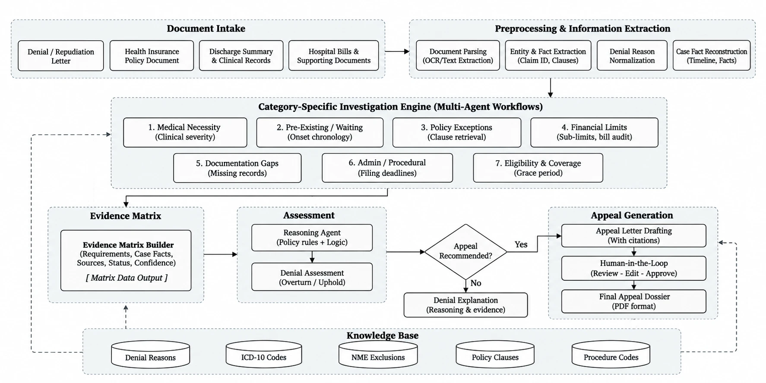
Fig 3.1: Proposed system architecture for claim denial analysis and appeal support

3.1.1 Document Intake
The user uploads the denial or repudiation letter, the policy wording, the discharge summary and other clinical records, and the hospital bills with supporting documents. Each file is stored in the case store and tagged with its document type.

3.1.2 Preprocessing and Information Extraction
Text is extracted with PyMuPDF and pdfplumber, and Tesseract OCR is used for scanned pages. An extraction agent then identifies the claim identifier, patient, insurer and product, dates of admission, discharge and denial, claimed and approved amounts, cited clause numbers and the stated reason. Diagnoses and procedures are normalized against the ICD-10-CM and procedure code tables. The stated reason is matched against the denial-reason taxonomy to give one or more of the seven categories. Finally, the case facts are assembled into a single case record with a timeline of events.

3.1.3 Category-Specific Investigation Engine
Each denial category has its own investigation agent with a fixed set of checks. Table 3.1 lists the categories, the question each investigation answers and the main checks it performs. A case that falls into more than one category runs several investigations in parallel.
Table 3.1: Denial categories and their investigations
Category | Question answered | Main checks | Resources used
Medical necessity | Was the treatment clinically required? | Severity indicators in the record; duration of failed conservative treatment; match with documented indications; physician certification | Procedure-diagnosis map, code tables, policy clauses
Pre-existing disease and waiting period | Did the condition precede the policy, and can the insurer still rely on that? | Onset date from history; elapsed coverage; continuity of renewals; moratorium; proposal-form declarations | Policy clauses (waiting periods), case dates
Policy exclusion | Does the cited exclusion apply, or does an exception override it? | Scope of the cited clause; search for exceptions and cross-references; check exception conditions against the record | Policy clauses with exception text, code tables
Financial limit | Were limits and deductions calculated correctly? | Room-rent proportionate deduction; sub-limits and caps; line-by-line audit of non-payable items | Policy clauses (limits), non-payable items schedule
Documentation | Are the requested documents really missing? | Compare the insurer's request with documents already submitted; list items to obtain and from whom | Case store, document manifest
Administrative or procedural | Was the procedural objection valid? | Intimation and submission delays; reasons beyond the insured's control; network-hospital and emergency rules | Policy clauses (procedures), denial taxonomy
Eligibility and coverage | Was the patient covered on the treatment date? | Membership and age rules; grace period on renewal; credit for waiting periods after portability | Policy clauses (eligibility), case dates

3.1.4 Evidence Matrix
The findings of all investigations are collected in an evidence matrix. Each row holds a policy requirement, the case fact that bears on it, the source document and page, a status of supports, contradicts or insufficient, and a confidence value. The matrix is the single record that the reasoning step, the drafting step and the reviewer all work from.

3.1.5 Assessment
The reasoning agent evaluates the matrix with explicit rules for Boolean conditions, dates and amounts, following the policy-to-logic approach of Pokharel et al. [18]. It also builds a Toulmin argument for each disputed point, in which an applicable exception acts as a rebuttal to the insurer's claim [17]. The result is an assessment of overturn, uphold or partial approval, with justifications and a list of open questions. If key evidence is missing, the system asks for the missing documents instead of guessing.

3.1.6 Appeal Generation and Human Review
If an appeal is recommended, the system selects the grievance forum and deadline, and the drafting agent writes a letter in which every assertion cites a clause or record. A citation verifier checks each clause number and quotation against the source documents and sends failed items back for revision. The reviewer then reads the draft beside the evidence matrix and can edit, approve or reject it. Approved drafts are exported as a PDF dossier with the highlighted clauses and supporting records attached. If an appeal is not recommended, the system produces a plain explanation of why the denial appears justified, with the same evidence.

3.1.7 Knowledge Base
All stages read from a shared knowledge base: the policy clause base, the denial-reason taxonomy, the ICD-10-CM diagnosis codes, the procedure codes with the procedure-diagnosis map, and the schedule of non-payable items. These are described in Section 3.4.2.

3.1.8 Deployment View
Fig 3.2 shows how the components are deployed. A review dashboard talks to a FastAPI service. The agents run inside a LangGraph state machine and reach the knowledge base through Model Context Protocol (MCP) tool servers, which keeps data access in one place and makes every lookup auditable. The LLM is called through an external API, and the benchmark harness drives the same API during evaluation.
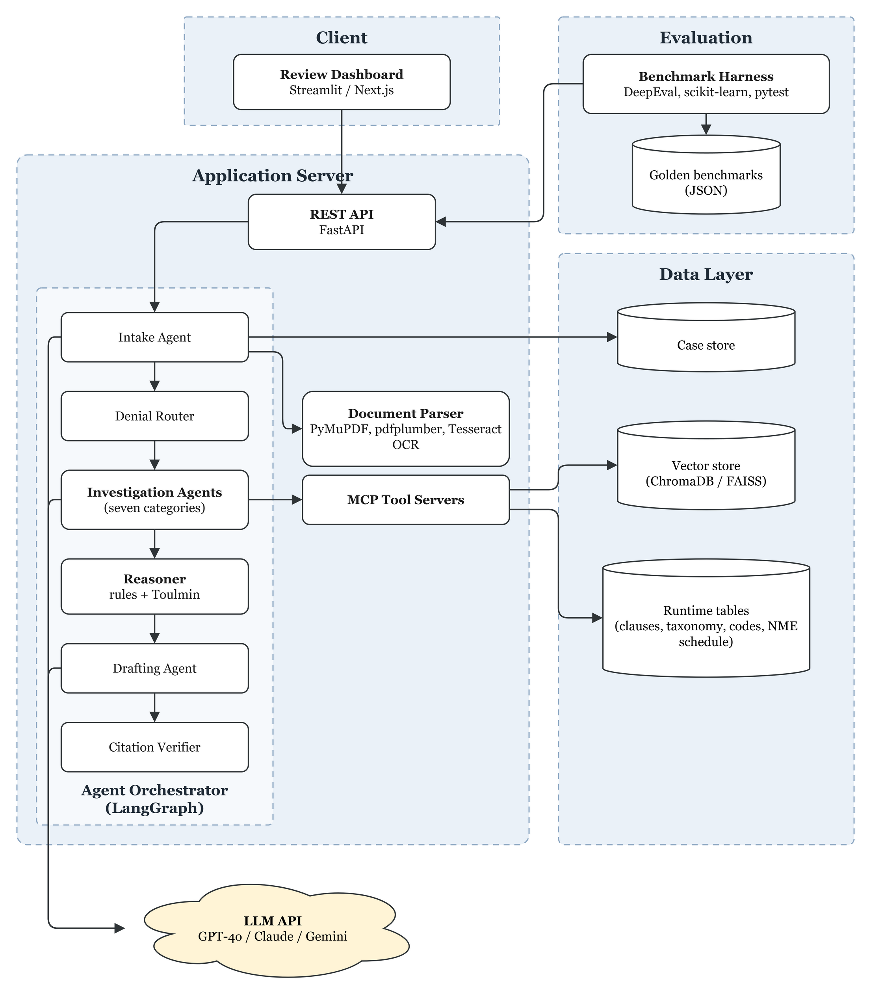
Fig 3.2: Component and deployment diagram of the proposed system

3.2 Data Flow and UML Diagrams
This section models the system from several viewpoints. Data flow diagrams show how information moves between external entities, processes and data stores. The UML diagrams show the actors and their goals, the main classes, the order of interactions, the control flow and the life cycle of a case.

3.2.1 Data Flow Diagram, Level 0
The context diagram in Fig 3.3 treats the whole system as one process. The insurer sends a denial letter to the policyholder, who passes it to the system with the policy and records. The system exchanges prompts and responses with the LLM service, receives knowledge base updates from public sources, sends drafts to the reviewer and receives approvals, and returns the assessment and final dossier to the policyholder.
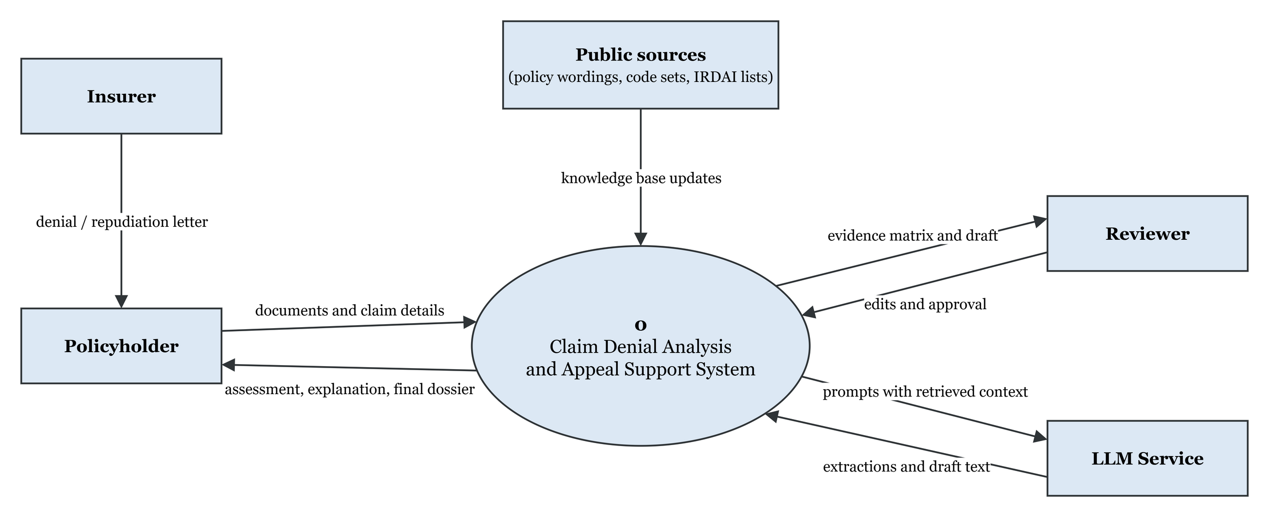
Fig 3.3: Data flow diagram, Level 0 (context diagram)

3.2.2 Data Flow Diagram, Level 1
Fig 3.4 breaks the system into seven processes and five data stores. Documents pass through intake (1.0) and extraction (2.0), which writes the case record to the case store (D1) using the code tables (D4). Categorization (3.0) uses the taxonomy (D3). The investigation (4.0) reads the case facts, policy clauses (D2), clinical indications (D4) and non-payable items (D5). Assessment (5.0) feeds either drafting with citation checks (6.0) or a direct explanation, and review and export (7.0) returns the final dossier.
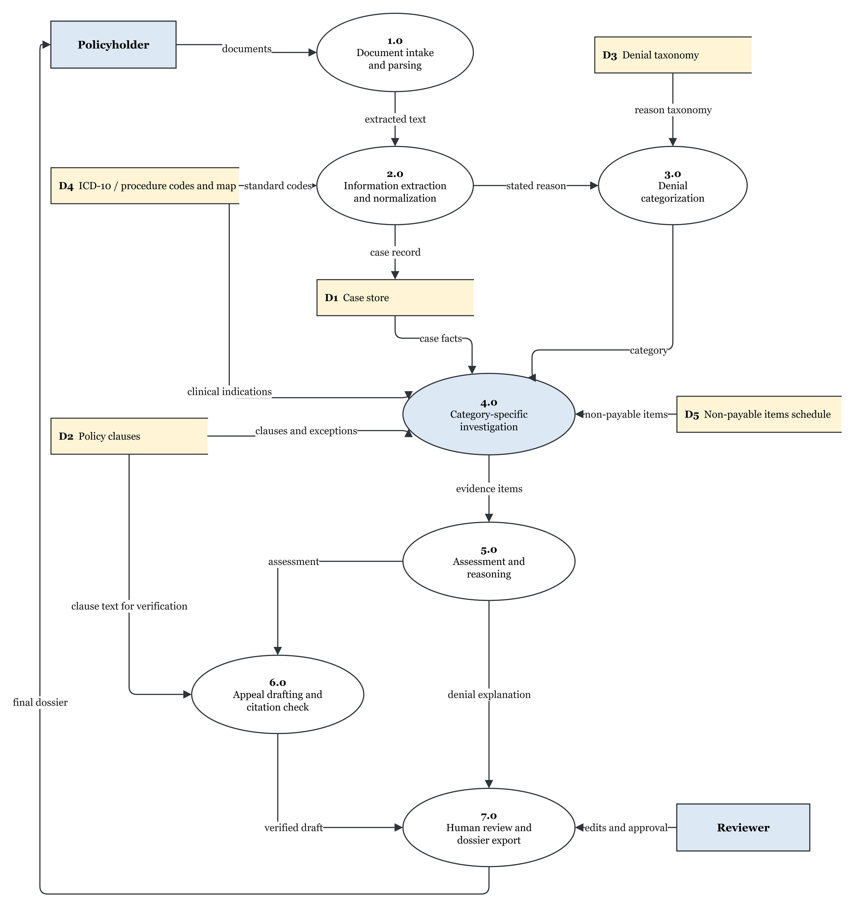
Fig 3.4: Data flow diagram, Level 1

3.2.3 Use Case Diagram
Fig 3.5 shows the actors and their use cases. The policyholder uploads documents, receives explanations and exports the final dossier. The reviewer works with the evidence matrix and approves drafts. The administrator maintains the knowledge base and runs the benchmarks. The LLM service is an external system actor. The include relations show the fixed sequence from upload to assessment. Drafting and explanation extend the assessment, depending on its outcome.
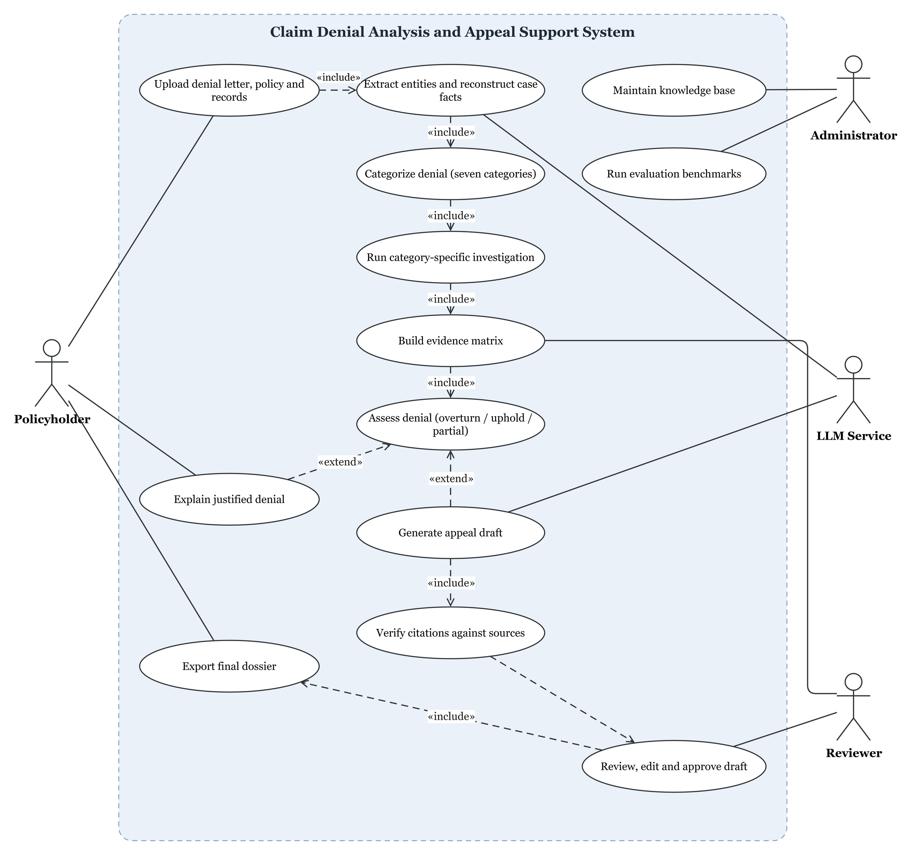
Fig 3.5: Use case diagram

3.2.4 Class Diagram
Fig 3.6 shows the main classes in three groups. In the case input group, a CaseRecord holds the source documents and the denial notice, whose categories come from the DenialCategory enumeration. In the investigation group, the abstract Investigation class has one subclass for each of the seven categories: MedicalNecessity, WaitingPeriod, PolicyExclusion, FinancialLimit, Documentation, Administrative and Eligibility. Every investigation retrieves PolicyClause objects and produces EvidenceItem objects, which are aggregated in an EvidenceMatrix. An Assessment draws on the matrix and on ToulminArgument objects whose warrants are policy clauses. AppealDraft, ReviewDecision and Dossier make up the rest of the reasoning and output group.
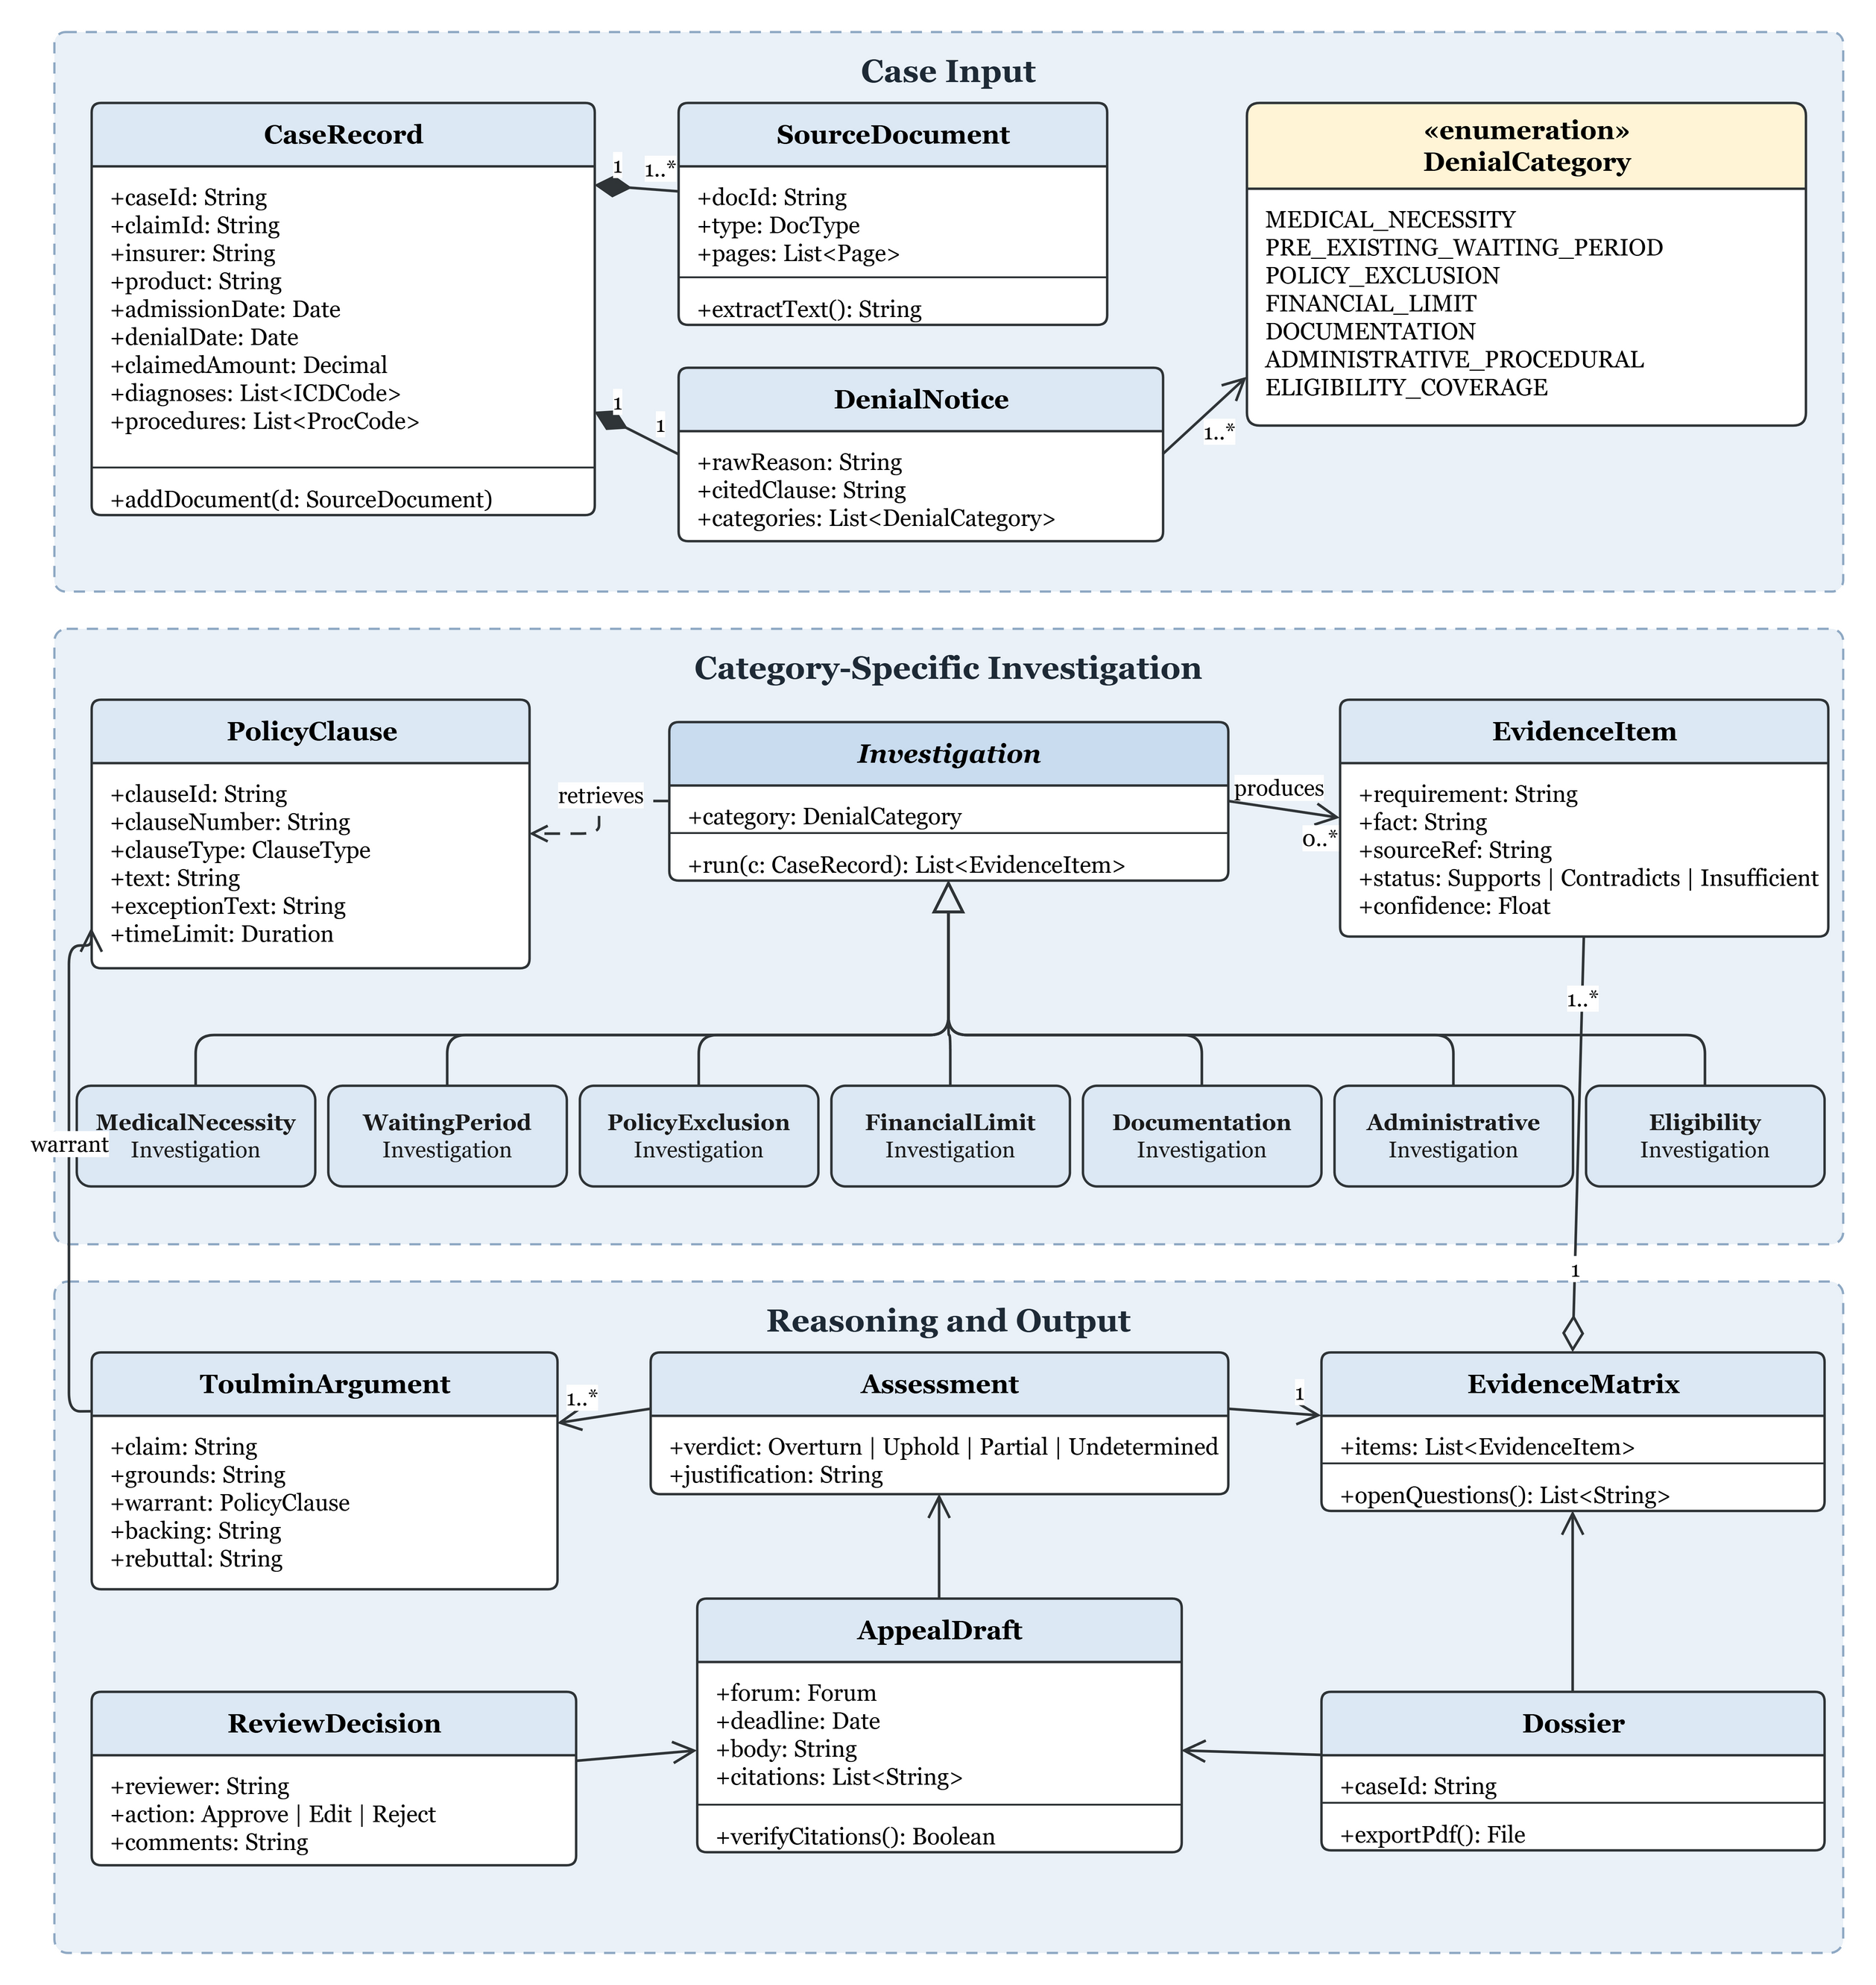
Fig 3.6: Class diagram

3.2.5 Sequence Diagram
Fig 3.7 shows the order of messages for a single case. The orchestrator calls the intake agent, the router and the investigation agent in turn, each consulting the knowledge base. After the reasoner returns an assessment, one of two branches runs. In the appeal branch, the draft loops through the citation verifier until it passes and then goes to the reviewer. In the other branch, an explanation is returned to the policyholder.
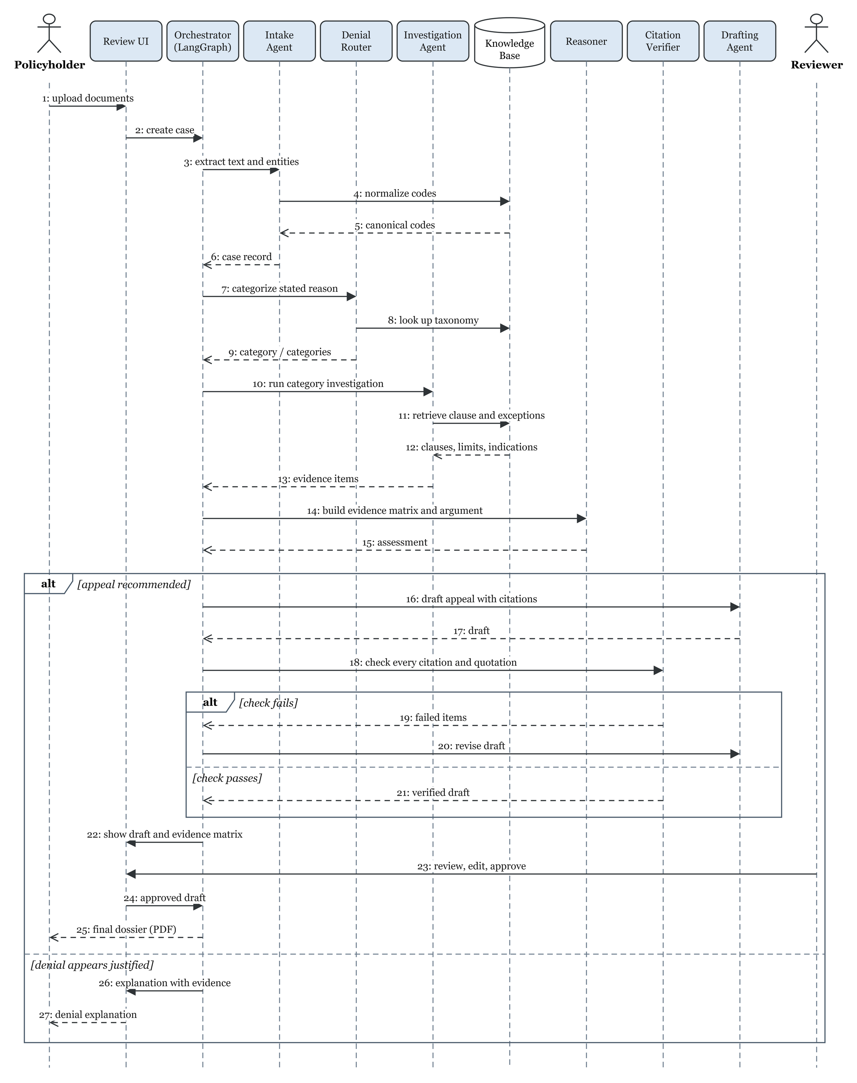
Fig 3.7: Sequence diagram for processing a denied claim

3.2.6 Activity Diagram
Fig 3.8 shows the control flow with its decision points: whether the case spans several categories, whether the evidence is sufficient, whether an appeal is recommended, whether all citations pass verification, and whether the reviewer approves. Clause retrieval and fact checking run in parallel within an investigation.
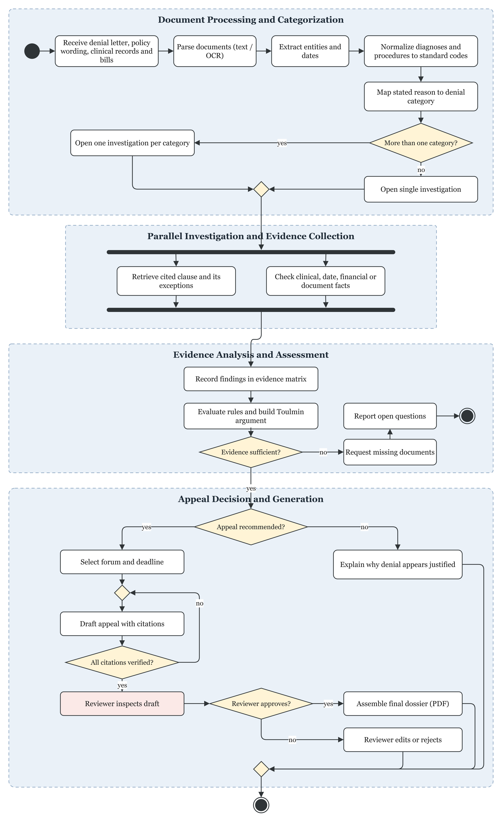
Fig 3.8: Activity diagram of the denial analysis workflow

3.2.7 State Diagram
Fig 3.9 shows the states a case passes through, from upload to export or closure. The loops between Drafting and Verification, and between InReview and Drafting, model the citation check and the reviewer's change requests. AwaitingDocuments models the pause while missing evidence is collected.
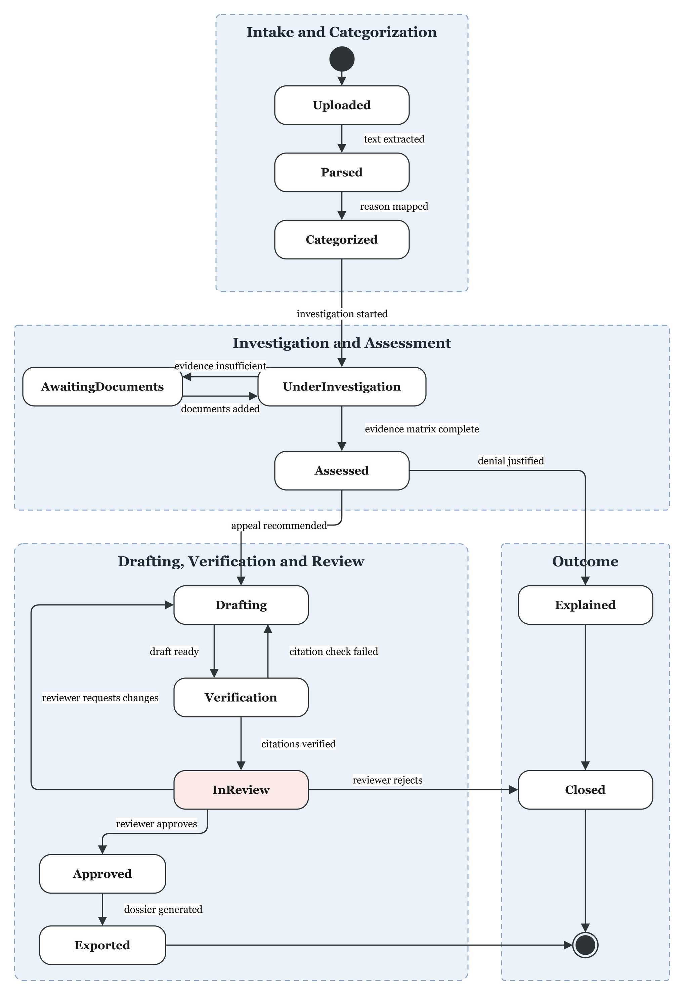
Fig 3.9: State diagram of a case

3.3 Algorithm Design
This section describes the main algorithms. They are written in pseudocode with the key formulas numbered.

3.3.1 Overall Orchestration
Algorithm 3.1 gives the top-level control flow that the LangGraph orchestrator follows for each case.
Algorithm 3.1: Denial analysis orchestration
Input: documents D (denial letter, policy, clinical records, bills)
Output: appeal dossier, or denial explanation
1 text <- PARSE(D) // PyMuPDF, OCR if scanned
2 case <- EXTRACT_ENTITIES(text) // claim id, dates, amounts, clauses
3 case.codes <- NORMALIZE(case, ICD10, PROC)
4 C <- CATEGORIZE(case.reason, TAXONOMY) // one or more of 7 categories
5 E <- empty evidence matrix
6 for each category c in C do in parallel
7 E <- E + INVESTIGATE(c, case, KB)
8 if INSUFFICIENT(E) then
9 return REQUEST_DOCUMENTS(E.open_questions)
10 A <- ASSESS(E) // rules + Toulmin arguments
11 if A.verdict in {OVERTURN, PARTIAL} then
12 (forum, deadline) <- SELECT_FORUM(case.dates, case.amount)
13 repeat
14 draft <- DRAFT_APPEAL(A, E, forum)
15 until VERIFY_CITATIONS(draft, D, KB)
16 return REVIEW_AND_EXPORT(draft, E)
17 else
18 return EXPLAIN_DENIAL(A, E)

3.3.2 Hybrid Clause Retrieval with Exception Attachment
Clause retrieval combines BM25 and dense embeddings and merges the two rankings with reciprocal rank fusion. For a passage d, the fused score is given by equation (3.1), where M is the set of retrievers, rank_m(d) is the position of d in the ranking of retriever m, and k is a smoothing constant, usually 60 [7].
RRF(d) = Σ_{m ∈ M} 1 / (k + rank_{m}(d)) (3.1)
Because the formula uses only rank positions, it can merge retrievers whose raw scores are on different scales. After fusion, every retrieved exclusion is returned together with the exceptions stored for it, so that the investigation never sees an exclusion on its own.
Algorithm 3.2: Clause retrieval with exception attachment
Input: query q, product p, clause base CB, top-k
Output: ranked clauses with their exceptions
1 S <- clauses in CB with product = p // metadata filter
2 R_sparse <- BM25_RANK(q, S)
3 R_dense <- EMBED_RANK(q, S)
4 for each clause d in R_sparse union R_dense do
5 score[d] <- 1/(60 + rank_sparse(d)) + 1/(60 + rank_dense(d))
6 R <- top-k clauses by score
7 for each clause d in R do
8 if d.has_exception then attach d.exception_text
9 attach clauses that d cross-references
10 return R

3.3.3 Chronology and Moratorium Check
Waiting-period denials are settled by date arithmetic. Elapsed continuous coverage in months is computed with equation (3.2), using the average month length of 30.4375 days.
T_{elapsed} = (D_{admission} − D_{inception}) / 30.4375 (3.2)
The onset of the condition is compared with the policy inception date to decide whether the condition existed before the policy began (equation 3.3).
PreExisting = 1 if D_{onset} < D_{inception}, otherwise 0 (3.3)
Under the IRDAI Master Circular on Health Insurance Business of 2024, once a policy has completed sixty months of continuous coverage it cannot be contested on grounds of non-disclosure or misrepresentation, except where fraud is established. The moratorium indicator is given by equation (3.4).
M = 1 if T_{elapsed} ≥ 60 months, otherwise 0 (3.4)
Algorithm 3.3: Waiting-period and moratorium decision
Input: inception, onset, admission dates; declared PED flag; waiting period W
Output: decision with reason
1 T <- (admission − inception) / 30.4375
2 if CONTINUITY_BROKEN(renewal history) then recompute T from last break
3 if T >= 60 then return REVERSE ("moratorium applies")
4 if onset >= inception then return REVERSE ("condition began after inception")
5 if T >= W then return REVERSE ("waiting period completed")
6 if not declared then return UPHOLD ("undisclosed pre-existing disease within waiting period")
7 return UPHOLD ("waiting period not completed")

3.3.4 Room-Rent and Non-Payable Item Audit
When a patient occupies a room above the policy's limit, insurers apply a proportionate deduction. The deduction ratio is given by equation (3.5).
R = min(1, Eligible room rent / Actual room rent) (3.5)
IRDAI guidelines restrict this deduction to charges that vary with the room category. Medicines, consumables, implants and diagnostic tests are not scaled. The payable amount for each bill item i is therefore given by equation (3.6).
Payable(i) = Billed(i) × R if i varies with room category, otherwise Billed(i) (3.6)
Each line item is also checked against the schedule of non-payable items. Items in List I are not payable. Items in Lists II to IV are included in room, procedure or treatment charges and should not be deducted again as separate items. The amount the policyholder can contest is the difference between what should have been paid and what was approved (equation 3.7).
Contestable = Σ_{i} Payable(i) − Non-payable items − Approved amount (3.7)

3.3.5 Toulmin-Based Applicability Evaluation
For each disputed point the reasoner builds an argument T = (C, G, W, B, R): the insurer's claim C, the grounds G from the case record, the warrant W given by the policy clause, its backing B, and the rebuttal R formed by any applicable exception or regulatory protection. The verdict function is shown in Algorithm 3.4. A confidence threshold θ guards against verdicts that rest on weak evidence.
Algorithm 3.4: Toulmin applicability evaluation
Input: argument T = (C, G, W, B, R), evidence matrix E, threshold θ
Output: SUPPORTS_DENIAL, CONTRADICTS_DENIAL or INSUFFICIENT_EVIDENCE
1 if CONFIDENCE(G, E) < θ then return INSUFFICIENT_EVIDENCE
2 if W does not apply to the facts in G then return CONTRADICTS_DENIAL
3 if R is non-empty and every condition of R is met in E then
4 return CONTRADICTS_DENIAL // exception defeats the clause
5 return SUPPORTS_DENIAL

3.3.6 Citation Verification and Forum Selection
Before a draft reaches the reviewer, every clause number is looked up in the clause base for the correct product, and every quotation is matched against the source text. A quotation passes only if it appears in the source with at most minor whitespace or punctuation differences. Failed citations are returned to the drafting agent with the reason for failure. The forum is chosen from the timeline. The draft is addressed to the insurer's grievance redressal officer first. If the insurer has rejected the grievance or not replied within one month, the draft is addressed to the Insurance Ombudsman, provided it is within one year and the amount is within the Ombudsman's limit. Otherwise the consumer disputes commission is suggested.

3.4 Model Description

3.4.1 Agents and Models
Each agent is an LLM call with a fixed role, a prompt template and a structured output schema defined with Pydantic. Fixed schemas let the orchestrator validate every response before passing it on. The intake agent returns typed entities, the router returns categories with confidence values, the investigation agents return evidence items with source references, and the drafting agent returns a letter together with a list of its citations. General-purpose models such as GPT-4o, Claude and Gemini are used through their APIs at a low sampling temperature, so that repeated runs give consistent output. Text embeddings for dense retrieval are produced with sentence-transformers models (all-MiniLM-L6-v2 for speed and bge-large-en-v1.5 for accuracy) and stored in ChromaDB. The symbolic components are plain Python functions with unit tests, which makes their behavior exact and repeatable.

3.4.2 Knowledge Resources
Table 3.2 lists the knowledge resources, what each contains, and where the workflow uses it.
Table 3.2: Knowledge resources used by the system
Resource | Content | Used in
Policy clause base | Clauses from 13 retail policy wordings of four Indian insurers, with clause type, exception text and structured time limits | Clause retrieval, exclusion and waiting-period checks, citation verification
Denial-reason taxonomy | Typical denial reasons in seven categories, with CARC/RARC codes, IRDAI provisions and grievance routes | Denial categorization, forum selection
Diagnosis codes | Curated ICD-10-CM codes from all chapters, with billable status | Entity normalization, exclusion checks
Procedure codes | Curated CPT and HCPCS codes with their coding system | Entity normalization, sub-limit checks
Procedure-diagnosis map | Diagnoses that indicate each procedure, with the supporting CMS coverage policy | Medical-necessity investigation
Non-payable items schedule | Items in IRDAI Lists I to IV | Bill audit in the financial-limit investigation

The policy clause base is built from the published wordings of thirteen retail products from ICICI Lombard, Care Health, HDFC ERGO and Star Health. Clauses are segmented using each document's own numbering and headings. Each record stores the insurer, product, section, clause number, text, clause type (coverage, exclusion, definition or waiting period), any time limit as a structured value, and the exception text if the clause contains phrases such as "except", "unless", "provided that" or "subject to". The denial-reason taxonomy gives typical reasons for each of the seven categories, mapped to the ASC X12 Claim Adjustment Reason Codes and Remittance Advice Remark Codes, the relevant IRDAI provision and the Indian grievance route. The diagnosis and procedure tables are curated subsets of ICD-10-CM, CPT and HCPCS codes for conditions and procedures that commonly appear in disputed claims. The procedure-diagnosis map links each procedure to the diagnoses that indicate it, citing the CMS coverage policy for each link. The non-payable items schedule follows the four lists of the IRDAI annexure.

3.4.3 Evaluation Benchmarks
Each component is evaluated on its own benchmark so that errors can be traced to the stage that caused them. The benchmarks are synthetic. They are generated from templates whose values come from the policy wordings, the code sets and public records of denials and appeals, and every ground-truth value can be traced to the case input or to the knowledge base. Table 3.3 summarizes them.
Table 3.3: Component-level evaluation benchmarks
Benchmark | Ground truth | Workflow stage | Main metrics
Intake | Fields stated in each denial letter (claim id, patient, insurer, product, dates, amount, cited clause, reason) | Preprocessing | Field accuracy, exact match, token F1
Clause retrieval | Governing clause, its exceptions and same-product distractors from the clause base | Exclusion and waiting-period checks | Hit@k, MRR, context precision and recall
Clinical evidence | Checklist items and evidence spans copied verbatim from clinical notes, with expected determination | Medical-necessity investigation | Checklist accuracy, faithfulness
Chronology | Elapsed coverage, waiting-period and moratorium status | Waiting-period investigation | Exact match, date error
Reasoning | Toulmin components and verdict for all seven categories, justified and unjustified denials | Assessment | Verdict accuracy, completeness, judged soundness
Appeal drafting | Product-specific clause citations, evidence and forum, with a reference letter | Drafting | Citation precision and recall, edit ratio
Denial routing | Category of each denial paragraph, balanced across seven categories | Denial categorization | Macro-F1, confusion matrix

3.4.4 Evaluation Metrics
Precision P is the fraction of predicted items that are correct, and recall R is the fraction of correct items that the system finds. The F1 score is their harmonic mean (equation 3.8). For denial routing, the macro-averaged F1 score gives each of the seven categories equal weight (equation 3.9), so strong results on common categories cannot hide failures on rare ones.
F1 = 2PR / (P + R) (3.8)
Macro-F1 = (1/7) Σ_{c=1}⁷ F1_{c} (3.9)
For retrieval, Hit@k is the fraction of queries for which a governing clause appears in the top k results, and mean reciprocal rank rewards placing it near the top (equation 3.10), where Q is the set of queries and rank_q is the position of the first governing clause for query q.
MRR = (1/ (Q)
Context precision and context recall measure how much of the retrieved text is relevant and how much of the needed information was retrieved [23]. Faithfulness is the share of statements in an output that the source text supports. Citation precision is the share of citations that support their statements, and citation recall is the share of required citations that appear [22]. The edit ratio, based on the Levenshtein distance between the draft and the version the reviewer approves, estimates how much correction was needed. Reasoning quality that cannot be checked exactly is scored with G-Eval, where an LLM rates the output against a written rubric [25].
These checks run at three levels. Level 1 uses exact comparisons such as exact match, date arithmetic and F1. Level 2 uses an LLM judge with reference answers for faithfulness and context recall. Level 3 evaluates the whole workflow with human reviewers, including citation support and editing effort. LLM judges can be inconsistent, so their scores are calibrated against a sample of human ratings.

3.5 Innovation and Novelty
The project differs from the reviewed work in the following ways:
- Every assertion in the final appeal can be followed back through the evidence matrix to a specific clause or record. None of the reviewed systems keeps this link from the denial notice to the approved appeal.
- Each of the seven denial categories has its own set of checks instead of one generic prompt. This extends the checklist design of prior-authorization systems to the full range of Indian denial reasons.
- The clause base stores each exclusion with its exception, and the reasoner treats exceptions as Toulmin rebuttals, which addresses the weakness observed in current LLMs.
- Waiting periods, the moratorium, room-rent deductions and non-payable items are computed by rules, while LLMs are used only for reading and writing.
- A separate verifier checks every clause number and quotation against the source documents, so the reviewer sees only drafts whose references exist.
- Evidence is marked as supporting, contradicting or insufficient, and the system asks for missing documents instead of guessing.
- The knowledge base uses Indian policy wordings, IRDAI rules and annexures, and Indian grievance routes, an area the reviewed literature does not address.
- Separate benchmarks for intake, retrieval, clinical evidence, chronology, reasoning, drafting and routing allow each error to be traced to its source.

REFERENCES

[1]. López, V. et al. (2021) 'Towards protecting vital healthcare programs by extracting actionable knowledge from policy', Findings of the Association for Computational Linguistics: ACL-IJCNLP 2021, pp.3509-3521. doi:10.18653/v1/2021.findings-acl.308.
[2]. Picco, G. et al. (2022) 'Learning insurance benefit rules from policy texts with small labeled data', MEDINFO 2021: One World, One Health, Studies in Health Technology and Informatics, Vol.290. doi:10.3233/SHTI220081.
[3]. Sbodio, M.L. et al. (2024) 'Collaborative artificial intelligence system for investigation of healthcare claims compliance', Scientific Reports, Vol.14, Article 11884. doi:10.1038/s41598-024-62665-0.
[4]. Kumar, M., Ghani, R. and Mei, Z.-S. (2010) 'Data mining to predict and prevent errors in health insurance claims processing', Proceedings of the 16th ACM SIGKDD International Conference on Knowledge Discovery and Data Mining, pp.65-74. doi:10.1145/1835804.1835816.
[5]. Lewis, P. et al. (2020) 'Retrieval-augmented generation for knowledge-intensive NLP tasks', Advances in Neural Information Processing Systems, Vol.33, pp.9459-9474.
[6]. Robertson, S. and Zaragoza, H. (2009) 'The probabilistic relevance framework: BM25 and beyond', Foundations and Trends in Information Retrieval, Vol.4, No.1-2, pp.1-174. doi:10.1561/1500000019.
[7]. Cormack, G.V., Clarke, C.L.A. and Buettcher, S. (2009) 'Reciprocal rank fusion outperforms Condorcet and individual rank learning methods', Proceedings of the 32nd International ACM SIGIR Conference on Research and Development in Information Retrieval, pp.758-759. doi:10.1145/1571941.1572114.
[8]. Hanmante, S., Patil, S., Deshmukh, P.V. and Shahade, A.K. (2026) 'InsuranceRAG: A multi-module retrieval-augmented AI system for intelligent insurance assistance', Software Impacts, Vol.28, Article 100844. doi:10.1016/j.simpa.2026.100844.
[9]. Zhang, T., Kishore, V., Wu, F., Weinberger, K.Q. and Artzi, Y. (2020) 'BERTScore: Evaluating text generation with BERT', Proceedings of the International Conference on Learning Representations (ICLR).
[10]. Lui, S.J., Xiang, C. and Krishnaswamy, S. (2024) 'KAMEL: Knowledge aware medical entity linkage to automate health insurance claims processing', Proceedings of the AAAI Conference on Artificial Intelligence, Vol.38, No.21, pp.22797-22805. doi:10.1609/aaai.v38i21.30314.
[11]. Lui, S.J., Xiang, C. and Krishnaswamy, S. (2024) 'Knowledge aware automated health claims processing with medical ontologies and large language models', Proceedings of the AAAI Symposium Series, Vol.4, No.1, pp.199-209. doi:10.1609/aaaiss.v4i1.31794.
[12]. Ahsan, H. et al. (2024) 'Retrieving evidence from EHRs with LLMs: Possibilities and challenges', Proceedings of the Conference on Health, Inference, and Learning (CHIL), Proceedings of Machine Learning Research, Vol.248, pp.489-505.
[13]. Pandey, H.G., Amod, A. and Kumar, S. (2024) 'Advancing healthcare automation: Multi-agent system for medical necessity justification', Proceedings of the 23rd Workshop on Biomedical Natural Language Processing (BioNLP), pp.39-49. doi:10.18653/v1/2024.bionlp-1.4.
[14]. Owolabi, T. (2025) 'Transforming appeal decisions: Machine learning triage for hospital admission denials', JAMIA Open, Vol.8, No.1, Article ooaf016. doi:10.1093/jamiaopen/ooaf016.
[15]. Prakken, H. and Sartor, G. (2015) 'Law and logic: A review from an argumentation perspective', Artificial Intelligence, Vol.227, pp.214-245. doi:10.1016/j.artint.2015.06.005.
[16]. Toulmin, S.E. (2003) The Uses of Argument, Updated edition, Cambridge University Press, Cambridge. doi:10.1017/CBO9780511840005.
[17]. Liu, J. et al. (2026) 'InsLogicBench: An argumentation logic grounded benchmark for complex insurance claims adjudication', Proceedings of the 64th Annual Meeting of the Association for Computational Linguistics (Volume 1: Long Papers), pp.22592-22619. doi:10.18653/v1/2026.acl-long.1035.
[18]. Pokharel, R., Hassanzadeh, H.R. and Agrawal, A. (2026) 'From policy to logic for efficient and interpretable coverage assessment', AAAI Workshop on AI for Medicine and Healthcare (AIMedHealth), arXiv:2601.01266.
[19]. Kiser, K.J., Waters, M., Reckford, J., Lundeberg, C. and Abraham, C.D. (2024) 'Large language models to help appeal denied radiotherapy services', JCO Clinical Cancer Informatics, Vol.8, Article e2400129. doi:10.1200/CCI.24.00129.
[20]. McCarthy, C.J. et al. (2026) 'Decreasing administrative effort related to non-approval of image-guided procedures using large language models: The DENIED-AI pilot study', Academic Radiology, Vol.33, No.8, pp.3221-3231. doi:10.1016/j.acra.2026.04.021.
[21]. Ji, Z. et al. (2023) 'Survey of hallucination in natural language generation', ACM Computing Surveys, Vol.55, No.12, pp.1-38. doi:10.1145/3571730.
[22]. Gao, T., Yen, H., Yu, J. and Chen, D. (2023) 'Enabling large language models to generate text with citations', Proceedings of the 2023 Conference on Empirical Methods in Natural Language Processing, pp.6465-6488. doi:10.18653/v1/2023.emnlp-main.398.
[23]. Es, S., James, J., Espinosa Anke, L. and Schockaert, S. (2024) 'RAGAs: Automated evaluation of retrieval augmented generation', Proceedings of the 18th Conference of the European Chapter of the Association for Computational Linguistics: System Demonstrations, pp.150-158. doi:10.18653/v1/2024.eacl-demo.16.
[24]. Parasuraman, R. and Manzey, D.H. (2010) 'Complacency and bias in human use of automation: An attentional integration', Human Factors, Vol.52, No.3, pp.381-410. doi:10.1177/0018720810376055.
[25]. Liu, Y., Iter, D., Xu, Y., Wang, S., Xu, R. and Zhu, C. (2023) 'G-Eval: NLG evaluation using GPT-4 with better human alignment', Proceedings of the 2023 Conference on Empirical Methods in Natural Language Processing, pp.2511-2522. doi:10.18653/v1/2023.emnlp-main.153.

